**System Sequence Diagram: Add user**

**MAIN SUCCESS SCENARIO:**

1. The administrator goes to the administrator page and navigates to the “add a new person” menu
2. The administrator system asks the administrator to fill in the information and then click register.
3. The administrator system sends the information to the server.
4. The server adds a new user its database.
5. The user is now registered.

**Alternative Path:**

4a. The user cannot be registered

1. The input password doesn’t match twice

2. The user is already existing

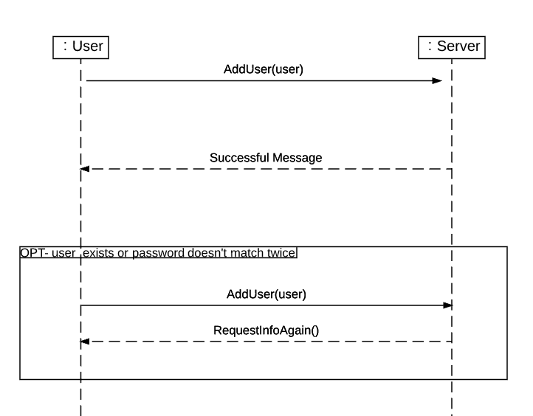

**System Sequence Diagram: Calibrate room boundaries**

**MAIN SUCCESS SCENARIO:**

1. The server requires user to walk into a certain room
2. The user tells the server he is here
3. Calibration happens

**Alternative Path:**

3. The user doesn’t move and tell the server he is here, and then the server would request user to try again.

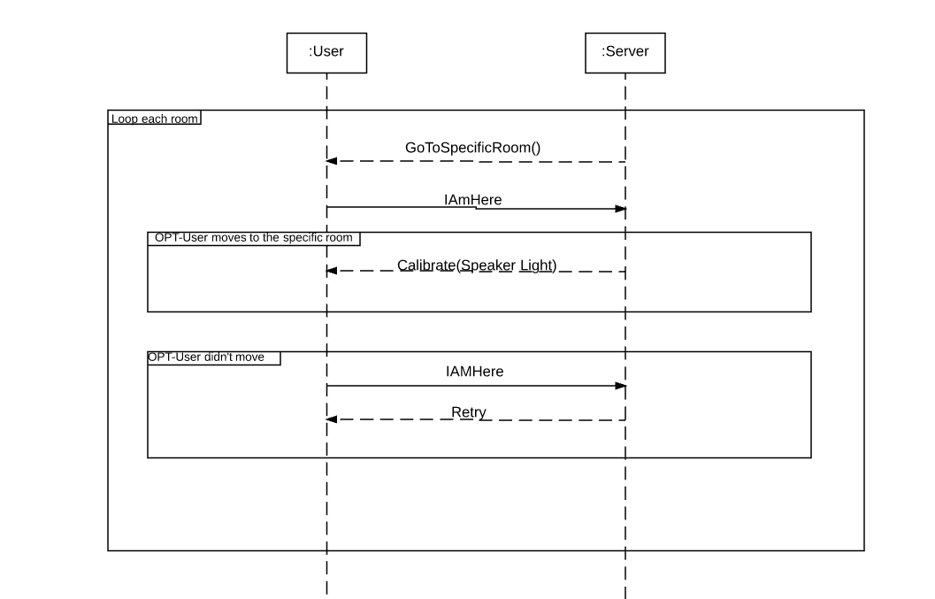

**System Sequence Diagram: Disable/remove speaker**

**MAIN SUCCESS SCENARIO:**

1. The user uses the mobile application and navigates to the “remove a device” menu
2. The mobile app displays the options of devices to remove
3. The user selects the speaker option.
4. The mobile app instructs the user to navigate the speaker and then click remove.
5. The mobile app sends the information to the server.
6. The server removes the speaker from its database.
7. The speaker is now removed.

**Alternative Path:**

4. The user cannot find the speaker

1. The speaker doesn’t exist
2. The speaker is currently used by a user

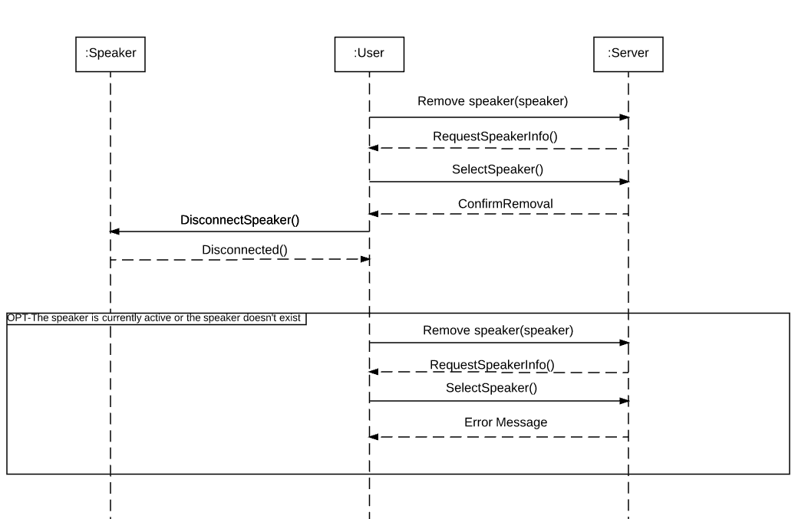

**System Sequence Diagram: Remove user**

**MAIN SUCCESS SCENARIO:**

1. The administrator goes to the administrator page and navigates to the “remove a user” menu
2. The page displays the options of users to remove
3. The page instructs the administrator to navigate the user and then click remove.
4. The administrator system sends the information to the server.
5. The server removes the user from its database.
6. The user is now removed.

**Alternative Path:**

4. The user cannot be removed

1. user doesn’t exist

2. administrator cannot be removed

3. user is currently using our system

